**Least Squares, Fourier, and Taylor Series Approximations**

A Fourier series can be written to approximate any function on any interval. If you approximate  on the interval , using an even Fourier series, you will find the following values for the coefficients  and  Note that each  is the coefficient of the term in the Fourier series.

|  |  |  |
| --- | --- | --- |
|  |  |  |

Thus, the function  approximates  on the interval . Graphs of compared to  are shown above.

If you studied BC Calculus you learned how to write Taylor polynomials to approximate values of non-polynomial functions. Taylor polynomials are designed to match function values and derivative values at a particular *x*-value. If you write a Taylor polynomial to match  at , you will use , i.e. the *n*th derivative evaluated at . The degree *2n* Taylor polynomial for  at is

.

|  |  |
| --- | --- |
| In the graph at right,  and  are shown.  For both the Fourier series and the Taylor series, increasing the number of terms in the series should result in a better approximation of .  The graph below shows  together with    and with  . |  |

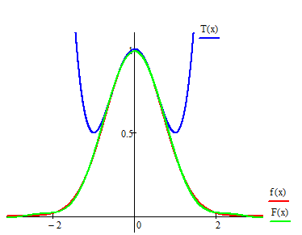

You can barely discern the differences between the three functions near the *y*-axis., but the Taylor approximation, since it is defined at a point rather than on an interval, quickly moves away from *f*.

Rather than relying on the appearance of graphs, you can quantify the error in the approximation made by either the Taylor polynomial or the Fourier function. The difference between the two functions and on the interval can be measured with the integral ; this is a “least squares” error measurement.

To measure the error in the 4th degree Taylor polynomial approximation to  on the interval , you should evaluate the integral  . To measure the error in Fourier function approximation to  on the interval , evaluate the integral .

EXERCISES

1. Compare the values of  , , and .
2. Explain why you should expect that  decreases as *k* increases.
3. Compare the values of  , , and .
4. Explain why you should expect that  decreases as *k* increases.
5. You should have found that the value of  is about and that the value of is about 0.00001437. These numerical values should seem consistent with the graph above that shows the three functions and . Referring to the criteria that were used to determine the coefficients in and the criteria that were used to determine the coefficients of in the Taylor series, explain why it is reasonable that is a better approximation of than is *over the* *interval from to .*
6. For what value of *k* does the value of  first become smaller than 0.001?
7. For what value of *k* does the value of  first become smaller than 0.00001?